1.Create a Basic Tutorial on How to Install a Prolog Compiler and Execute Prolog Code on Your Operating System.
----->
For Linux (Ubuntu/Debian):
Update package list
sudo apt update
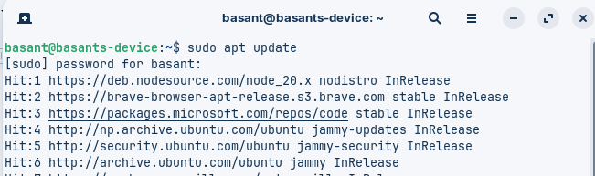
Install SWI-Prolog
sudo apt install swi-prolog

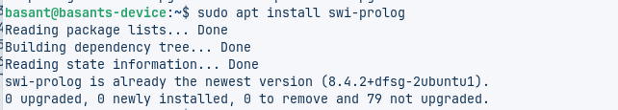
check if the prolog is installed
swipl –-version

